# 21F-9516

# Suresh Kumar

# BS (SE) 6A

# CN Lab 1

## Task 1: -

Ls:

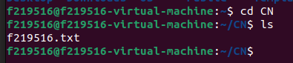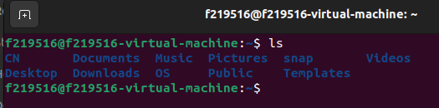

Cd:

Cp:

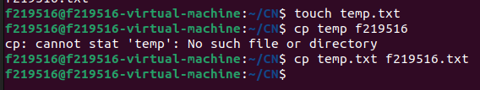

Mv:

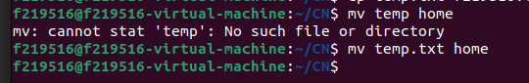

Rm:

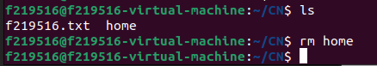

Pwd:



Mkdir:



Rmdir:



Less More Cat:

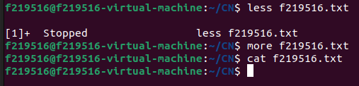

Man;

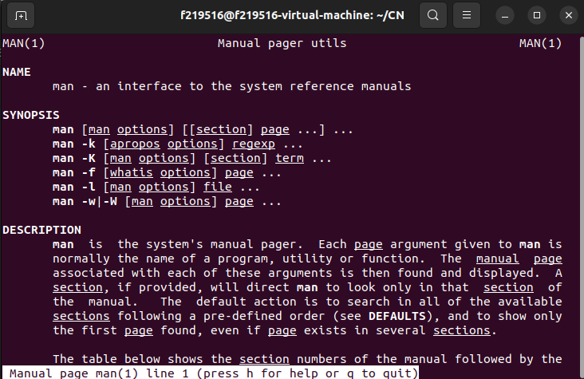

Whatis:

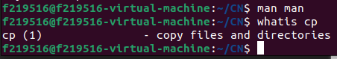

AddUser:

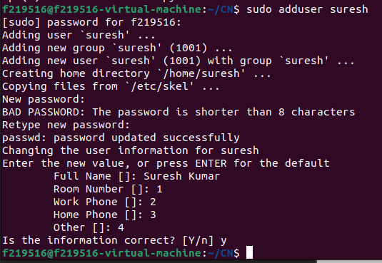

Passwd;

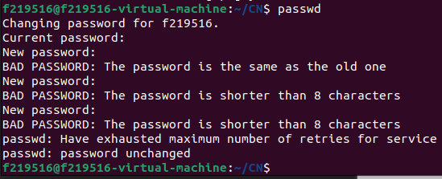

Su:



Df:

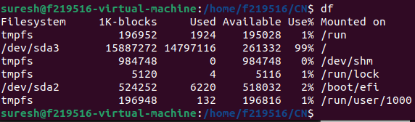

UserDel:



Chmod a+w;



Chmod o-x:



Chmod a+x:

